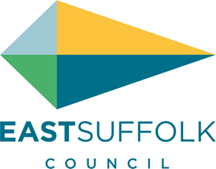

**September 2022**

Welcome to my monthly newsletter

**Helping East Suffolk Ease the Squeeze on cost of living**



As the UK continues to face a cost-of-living crisis, households are seeing huge increases in their outgoings.

As we head into the colder months, East Suffolk Council has a responsibility to help residents find the support they need.

That is why we have launched Ease the Squeeze – a comprehensive scheme which helps connect those needing help to those helping.

We are working closely with key partners on a number of local schemes, while also directing people to other available support and services.

All the information, including practical support, funding and advice, has been gathered on our website, at [www.eastsuffolk.gov.uk/squeeze](http://www.eastsuffolk.gov.uk/squeeze)

This page is continuously being updated as more schemes, services and support becomes available, so please share this with others.

We will also be running a social media campaign to raise awareness of the website.

Customer Services, Communities and Housing are working closely together to provide a wide range of support and advice.

And any concerns you may have or aware of any issues your neighbours have please do not hesitate to contact me .



**'Efficient, clean and super green' refuse lorries hit the streets of East Suffolk**

|  |  |
| --- | --- |
| East Suffolk Council has welcomed the addition of 'efficient, clean and super green' biofuel-powered trucks to its fleet of refuse collection vehicles.  The arrival of the vehicles on the streets of East Suffolk is the latest move towards switching the entire fleet to eco-friendly fuel.  Last year, the Council approved plans to switch its diesel fleet to be fuelled by HVO (Hydrotreated Vegetable Oil) and reduce total carbon emissions by more than 30%. |  |

An advanced renewable and sustainable fuel, HVO offers up to 90% reduction in carbon emissions compared to diesel.

The 246-vehicle fleet, mainly operated by waste management partners East Suffolk Norse, was the biggest single contributor to the Council's carbon footprint last year. A third the vehicles will initially be converted to HVO, including 60% of heavy goods refuse lorries. As your cabinet member for the environment I was really delighted to introduce this initiative, something really practical and meaningful in dealing with increasing environmental concerns .



**Strategy for sustainable and inclusive future of leisure and sports facilities**

This Council has renewed its commitment to improving the health and wellbeing of its residents by adopting a new strategy for leisure and sports provision.

The East Suffolk Leisure Strategy will help to ensure that the needs of the community are met by developing the provision of sport and physical activity across the district.

Key among the strategy’s will be to protect and enhance the existing supply of playing pitches and outdoor sports facilities where needed for meeting current and future demand.

The overarching strategy incorporates the Council’s Indoor and Built Sports Facilities Strategy (IBF), Playing Pitch and Outdoor Sport Strategy (PPOSS) and Open Space Report.

A total of 571 sports clubs responded consultation during the development stage of the documents, along with community groups, town and parish councils, schools, health partners and operators.

The resulting studies will prioritise areas most in need of improvement and identify ways to potentially improve existing shortfalls, while also helping the Council achieve its strategic objective of Enabling Communities by providing data that could assist with future funding bids for local improvements.

**Households urged to get Food Savvy and plan ahead to save money and avoid waste**

As the cost of living continues to bite a new campaign has been launched in Suffolk to help families reduce food waste and save money.

Back To Savvy is a Suffolk Waste Partnership initiative which advises people on how to reduce food waste through planning out meals and storing them effectively.

The campaign will advise on planning meals and batch cooking, storing prepared meals so they are ready for work/school, and repurposing leftovers into new meals.

The three main top tips are:

1. Cook today, eat tomorrow - cook multiple meals together using batch recipes and store in a fridge or freezer for later

2. Love your leftovers - turn dinner leftovers into tasty lunches or even remix them into fun new recipes.

3. Plan ahead - organise your lunches by planning and buying in advance. Even a minute planning your meals will save you a tonne of time and money.



**Community partnerships update on principle**

The Communities team comprises almost 30 experienced and dedicated individuals who work to deliver a huge range of community projects. The team drives towards the following outcomes:

• Better outcomes and quality of life for individuals, families, communities and organisations

• Resilient, connected, cohesive and inclusive communities

• Resilient, independent and safe individuals and families, particularly those who are vulnerable

• Reduced health inequalities and improved mental and physical health and wellbeing

• People and communities do more for themselves and, if necessary, can access the right service at the right time

The team works collaboratively with partners and communities to deliver these outcomes. In fact, the Communities team’s ethos is all about empowerment and enablement. This applies to our partners as well as our residents. We provide help and advice on understanding community need and in delivering the most appropriate projects; we offer access to a network of community leaders and volunteers; we have extensive experience in reaching out to all our communities and have senior marketing resource within the team; and we can bring together the most appropriate people to successfully deliver any project.

**Misc**

I continue to try and improve my ward – I have flagged up the footpath from Wilford roundabout to Sutton Hoo with Highways – which is now a safety concern, initial response from SCC stated it wasn’t an issue so I have asked them to look again

I was able to provide a new recycling bin for our friends at Sutton Heath :

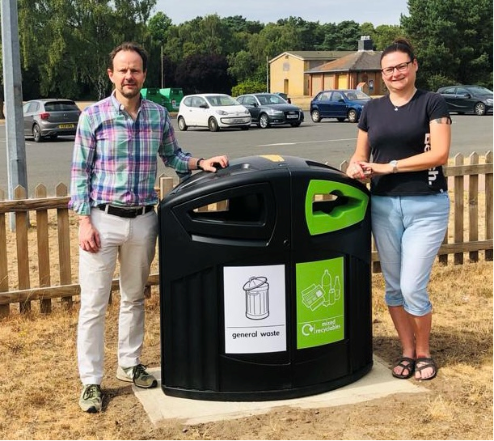

Organised road sweepers to attend Eyke

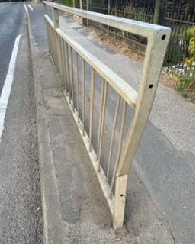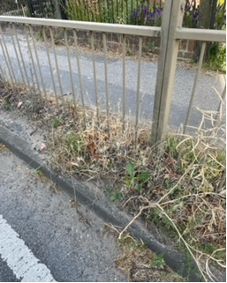

And I like to think you district councillor has friends in high places !

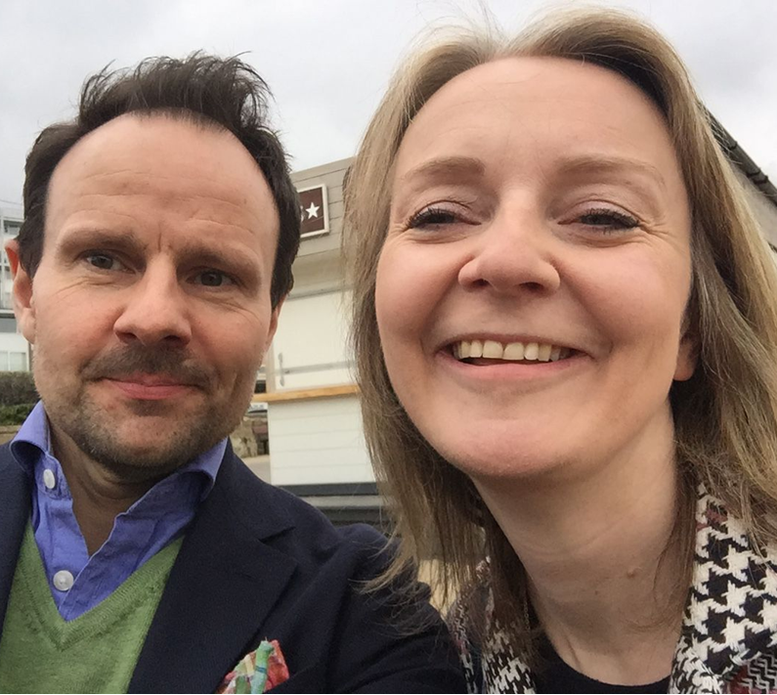

**James Mallinder**

**Deben Ward**

**Environment Portfolio holder**